EXPERIMENT 8

8.1.2 Prime Numbers in a given range

Algorithm:
Step 1: Start
Step 2: Input two integers:
  - start
  - end
Step 3: Initialize a boolean variable:
  - found ← False (to track if any prime number is found)
Step 4: Loop through each number num from start to end (inclusive):
a. Check if num > 1
  - If not, skip to the next number
b. Assume the number is prime:
  - prime ← True
c. Check divisibility:
  - For each i from 2 to √num (inclusive):
    - If num % i == 0:
      - Set prime ← False
      - Break the loop
d. If prime == True:
  - Print num
  - Set found ← True
Step5: After loop ends:
  - If found == False:
    - Print "No primes"
Step 6: End

Flowchart:

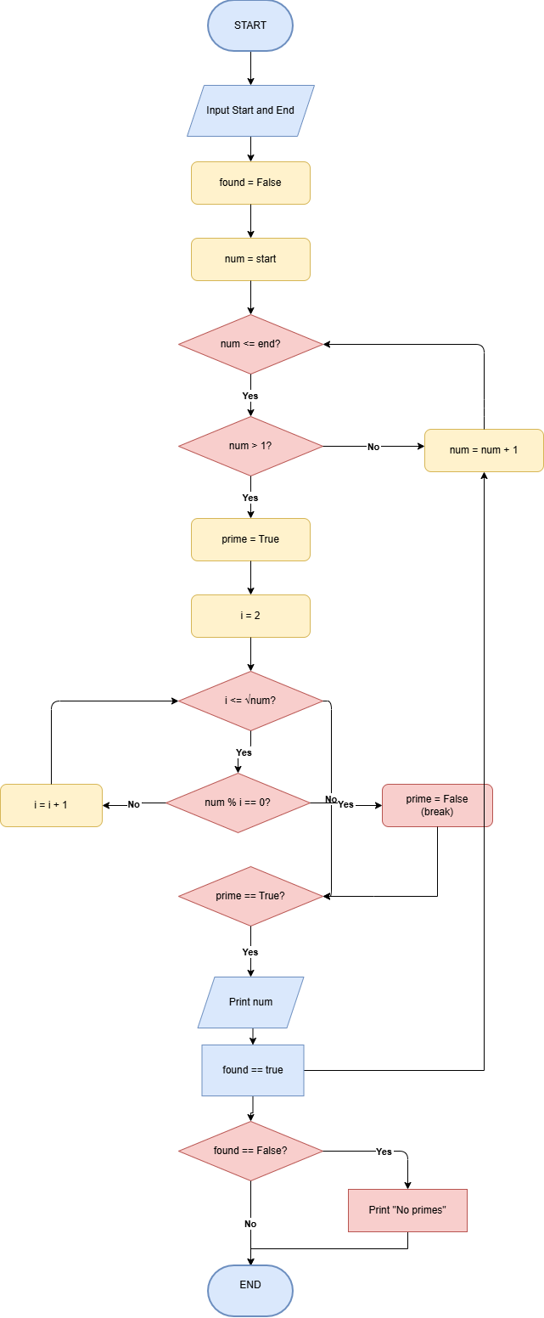

Code:
start = int(input())
end = int (input())
found = False
for num in range(start, end + 1):
if num > 1:
prime = True
for i in range(2, int(num ** 0.5)+1):
if num % i == 0:
prime = False
break
if prime:
print(num)
found = True
if not found:
print("No primes")

Execution:
